**Task 20: Pods and Services in Kubernetes Deployment**

Connect an instance install awscli

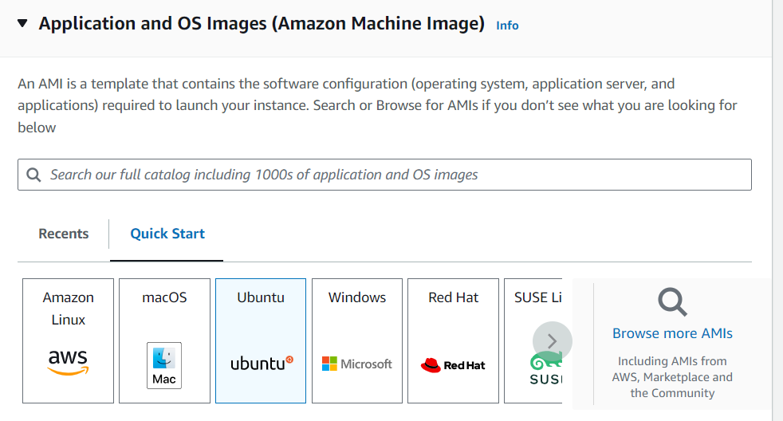

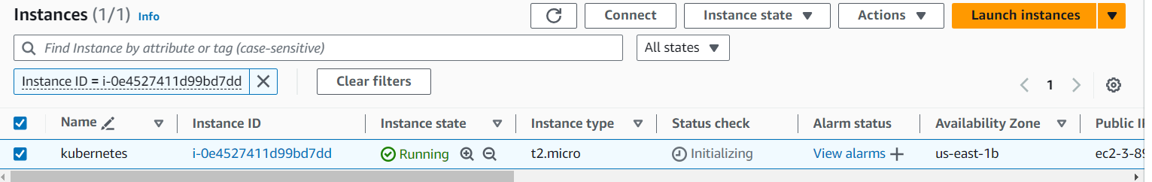



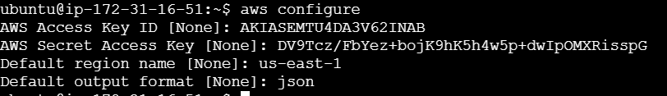

1. **Install kubectl**

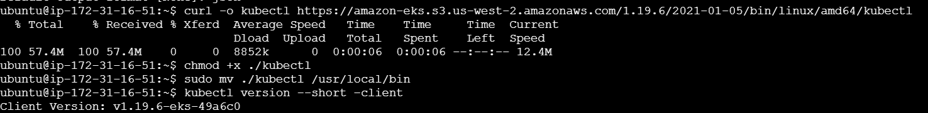

1. **Install eksctl:**

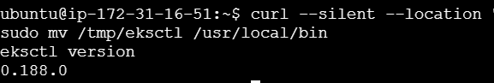

**Create a Kubernetes cluster**



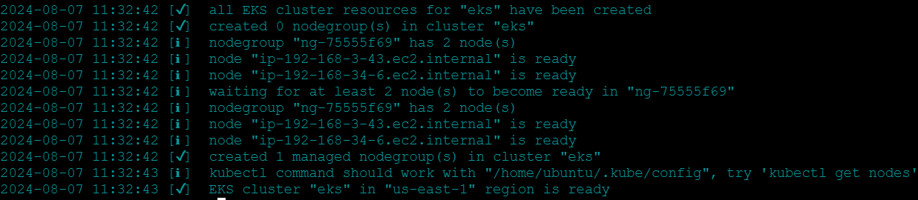

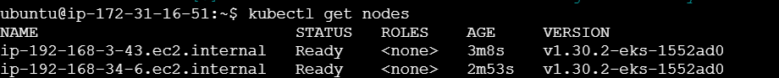

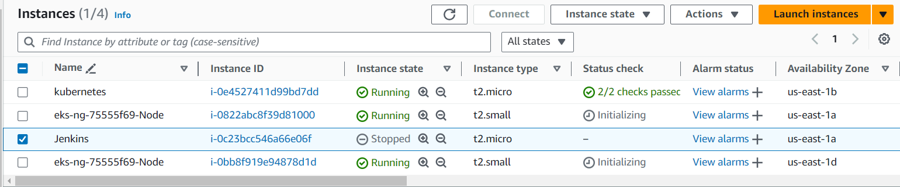

1. **Deployment file:**

vi deployment.yaml

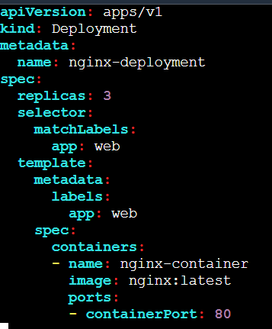

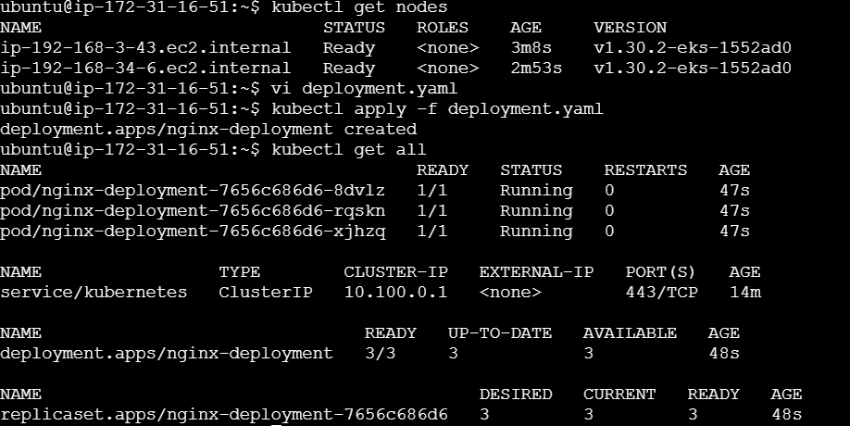

**Execute deployment.yaml file:**

kubectl apply -f deployment.yaml

1. **Service.yaml file:**

vi service.yaml

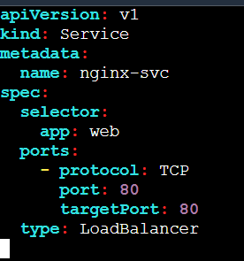

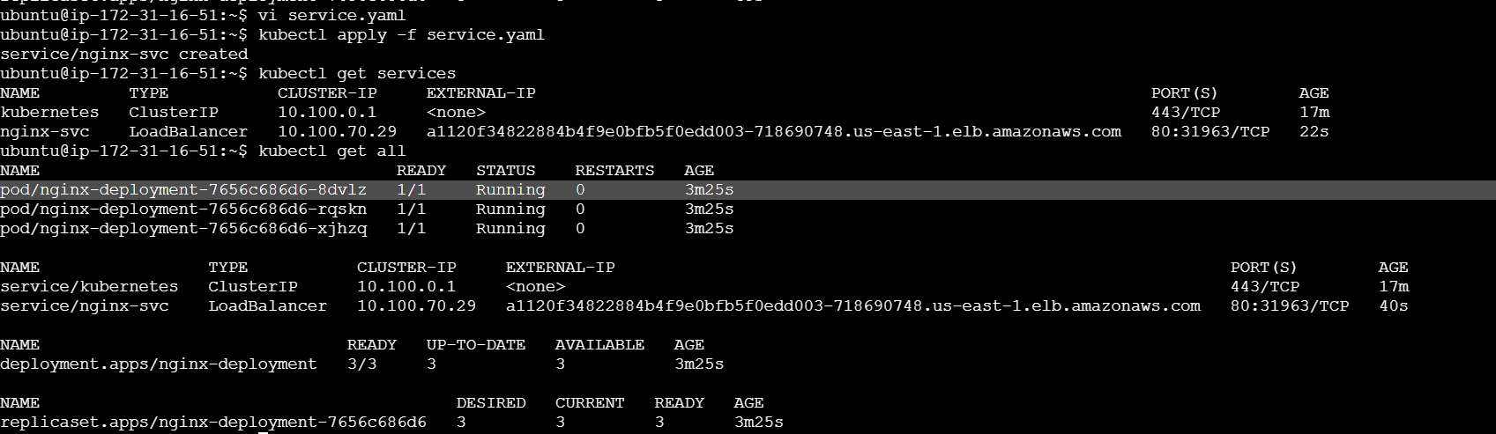

**Execute service.yaml file:** kubectl apply -f service.yaml

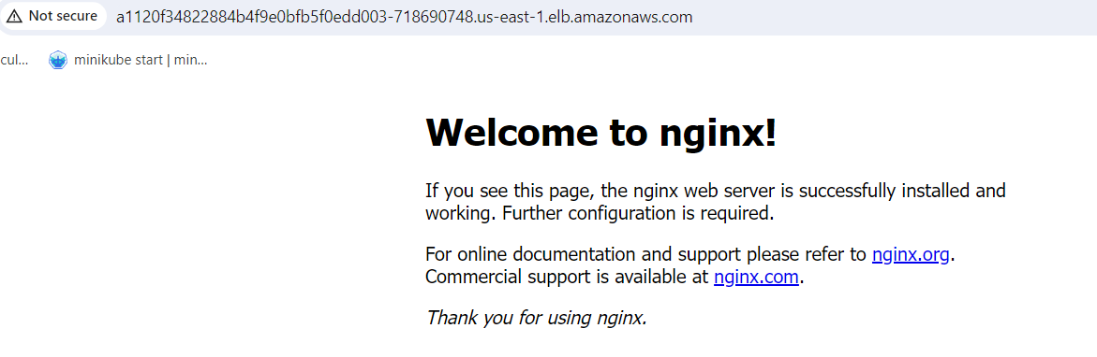

1. **Pod.yaml file:**

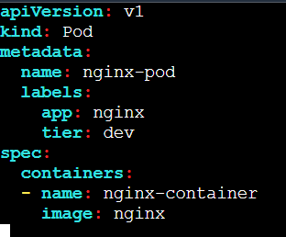

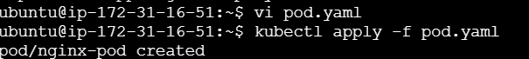

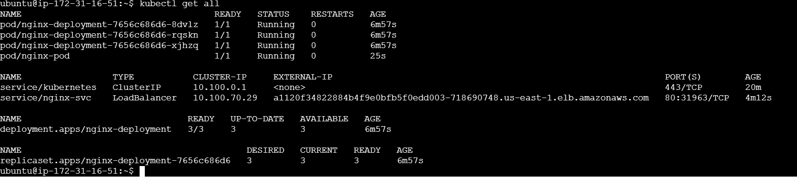

**Execute pod.yaml file:**

kubectl apply -f pod.yaml